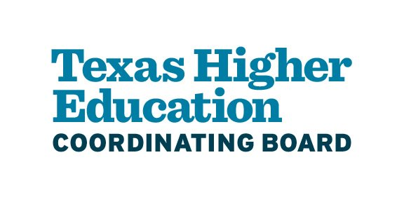

APPLICATION FORMS

GEER II-Nursing Innovation Grant Program
(GEER II-NIGP)

Application Forms
2023

BMS #28384

APPLICATION DEADLINE: NO LATER THAN 11:59 p.m. CST, NOVEMBER 30, 2022

GEER II-NURSING INNOVATION GRANT PROGRAM

CERTIFICATION OF APPLICATION INFORMATION (FORM 1)
Applicant Institution:

Total Funding Requested for Period Ending 08/31/2023:
$

Authorized Institutional Representative’s Name and Title (typed):

Chief Academic/Instructional Officer’s Name and Title (if different from above) (typed):

I certify that the statements herein are true, complete, and accurate to the best of my knowledge. I further certify that if OER program funds are awarded, this institution accepts the obligation to comply with terms and conditions set by the Texas Higher Education Coordinating Board.

__________________________________________ ________________________________
Authorized Institutional Representative Signature Date

___________________________________________ ________________________________
Chief Academic/Instructional Officer Signature Date

Contact Person’s Name and Title in Office of Sponsored Projects/Grants Management Office (typed):

Name:
Title:
Phone:
Email:

GEER II-NURSING INNOVATION GRANT PROGRAM

Project Narrative (FORM 2)
Contact Information – Applicant Institution
Applicant Institution (typed):

Institution:
Phone:
Email Address:
Mailing Address:

Primary Faculty Contact (typed):

Name:
Title:
Phone:
Email Address:

Contact Information – Partner Institution(s), if applicable
Partner Institution(s) (typed):

Institution:
Phone:
Email Address:
Mailing Address:

Primary Faculty Contact at Partner Institution(s) (typed):

Name:
Title:
Phone:
Email Address:

See the Request for Applications (RFA) Section 8.2 at GEER II-Nursing Innovation Grant Program - THECB (texas.gov) for details:

- Project Summary (RFA Section 8.2.2)
- Description of Applicant and Partners (RFA Section 8.2.3)
- Assessment of Need (RFA Section 8.2.4)
GEER II-NURSING INNOVATION GRANT PROGRAM

PROJECT WORK PLAN OR TIMELINE (FORM 3)
Applicant Institution:

See the RFA Sections 8.3 and 8.4 at GEER II-Nursing Innovation Grant Program - THECB (texas.gov) for details:
- Project Goal Statement (RFA Section 8.3.1)
- Major Project Objectives and Expected Outcomes (RFA Section 8.3.2)
- Project Evaluation (RFA Section 8.4)

GEER II-NURSING INNOVATION GRANT PROGRAM

PROJECT BUDGET (FORM 4)
Applicant must complete the Budget. A separate budget must be submitted for each Partner that would participate in GEER II-Nursing Innovation Grant program funding. The budget must include:
- A reasonable estimate of funds expenditures over the Grant Period; and
- Amounts and justification of allowable funds expenditures by category and year (Refer to Section 6.2 of RFA)
THECB shall negotiate a Final Award Budget with each Awarded Applicant.

Example Budget Form:
Applicant: | Institution:
Budget Detail By Category | Amount
A. Category 1
Item | $
Description

B. Category 2
Item | $
Description

Request Total | $
Total Funding for Grant Period | $

